1. **Keep image aspect ratio**

If you apply min-height to the image, or min-width, it will incorrectly change the aspect ratio.

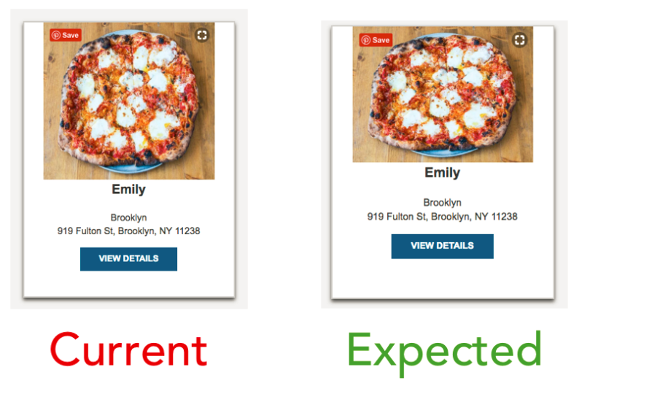

1. When using the service worker, always cache like this, to ensure all files will we saved in the cache
2. self.addEventListener('install', function(event) {
3. event.waitUntil(
4. caches.open(staticCacheName).then(function(cache) {
5. return cache.addAll([
6. **'/',**
7. 'data/restaurants.json',
8. '/public/js/main.js',
9. … … …
10. ]);
11. })
12. );
13. });

3. Add detailed description for the “alt” of the images

image.alt ='Restaurant of ' + restaurant.name + ' with cuisine type of ' + restaurant.cuisine_type;

**4. Add description always to buttons like**

image.alt ='Restaurant of ' + restaurant.name + ' with cuisine type of ' + restaurant.cuisine_type;

so the person will know where it will take them even if they do not see.

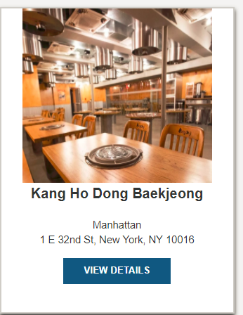

The trick is to add a span into the button, which is hidden from the visble users

<a href="./restaurant.html?id=3">View Details

<span>Link to the Kang Ho Dong Baekjeong</span>

</a>

#restaurants-list li a span {

height: 1px;

width: 1px;

position: absolute;

overflow: hidden;

top: -10px;

}

5. Create **skiplinks** to avoid a lot of uneccesary tabs

<a class="skip-link" href="#options">Skip map and go to options</a>

On **:focus** it will appear and will jump to the inner link of **#options**

6. Google maps should have a **role=application + title=map**

<section id="map-container">

<div role="application" aria-hidden="true" id="map" title="google-map"></div>

</section>

**7.BreadCrumbs** should always have **aria-current** attribute of **page**

fillBreadcrumb = (restaurant=self.restaurant) => {

const breadcrumb = document.getElementById('breadcrumb');

const li = document.createElement('li');

li.innerHTML = restaurant.name;

li.setAttribute("aria-current","page");

breadcrumb.appendChild(li);

}

**8. Using gulp-image resize**

<https://stackoverflow.com/questions/41071318/error-eof-when-trying-to-resize-images-using-gulp-on-windows?utm_medium=organic&utm_source=google_rich_qa&utm_campaign=google_rich_qa>

**9 When using service workers**

1. Always delete the caches
2. Go to service worker – “Unregister the current service worker”
3. Close the tab and open in a new one